**TEAM 19 PHASE 2**

TEAM MEMBERS WITH THEIR UTA IDS:

Anande, Saahil (1001855308)  
Pagare, Richa (1001873138)  
Sharma, Satvik (1001868047)

**INITIAL ER**

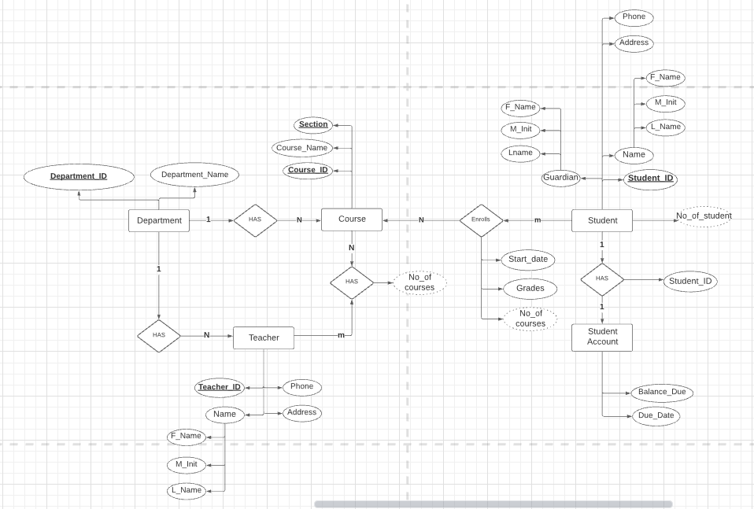

**REVISED ER**

